# Add new company

Adding a new company is initialized from the companies grid page.

We create a button **“Add company”** (label is translatable).

Upon clicking the button, we go to a new page, first a generic search box is presented:

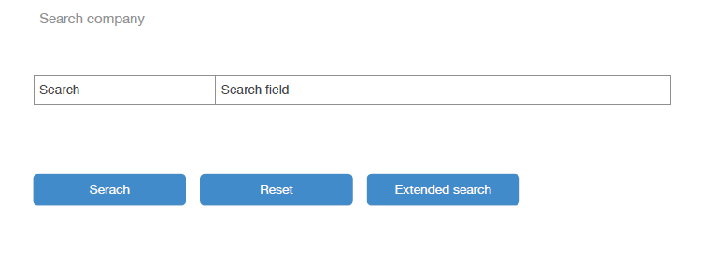

This box will search our local chamber of commerce for the search term**. For this an existing API will be used. See included php file for a prototype class. This php file starts with credentials (commented), please put those in the ENV file of your project.**

For instance, we want to add the company “Creditdevice B.V.” to our database (in this example it does not exist yet). We could manually enter all the details of the company, if we have these directly available. Creditdevice B.V. is registered in the Dutch Chamber of Commerce (company registration agency). We already developed a webservice to obtain the basic information of every company by searching on their database. This webservice is included as the prototype class. In short, we use the webservice to get essential company information from another database from another agency, to help us pre-fill fields for creating the company. See the animated gif for a similar use-case (but not the same). This use-case demonstrates the use of a company search box, giving the results and selecting the company.

**Not mentioned in these wireframes is a button to directly go to a form which allows you to go to the edit-screen where you can manually enter all details. So we get the buttons “Search”, “Reset”, “Extended search”, “Skip search”**

In the first screen a generic “term” argument can be used, the webservice will then automatically try to match the best result for that term. Extended search will open more search fields: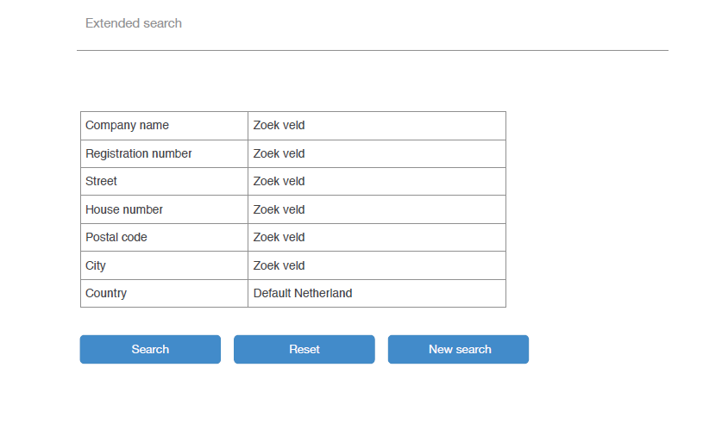

Each field translates to the search api search parameters (see php script).

The only difference between the webservice interaction is that the previous page only takes a “term” argument to the webservice request. In this advanced search, company name, registration number etc are all used in the webservice request, giving you the option to do an EXACT search.

## Search result

Upon searching (by the generic term, sketch 1, or the advanced seach, sketch 2), the results page is opened. Displaying the resultset from the webservice (the webservice gives back json result).

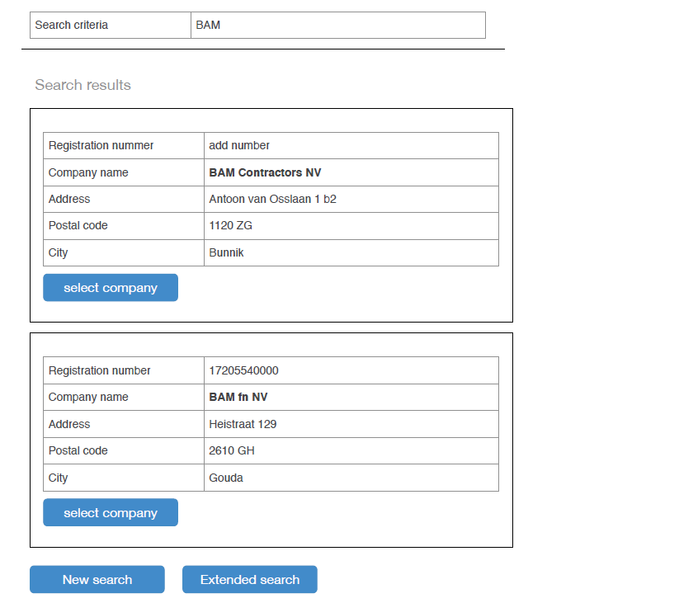

Be aware that the search form is included in the search results. The best option here would be: display the search form again, with entered search term/terms, below that, show the search results.

Clicking on “select company” will forward the user to the edit screen,

screen above.

Here the data from the selected company is filled in the form. This can be done in two ways: either clicking “Select company” in previous screen posts the data to the edit form and sets the registration number, company name, address etc. in the form below.

Second option: only the chamber of commerce number (= registration number in the form below) is posted to the form from the previous screen when one clicks “Select company”, the edit-form request will then do another webservice request with that chamber of commerce number and gets the data for that registration number.

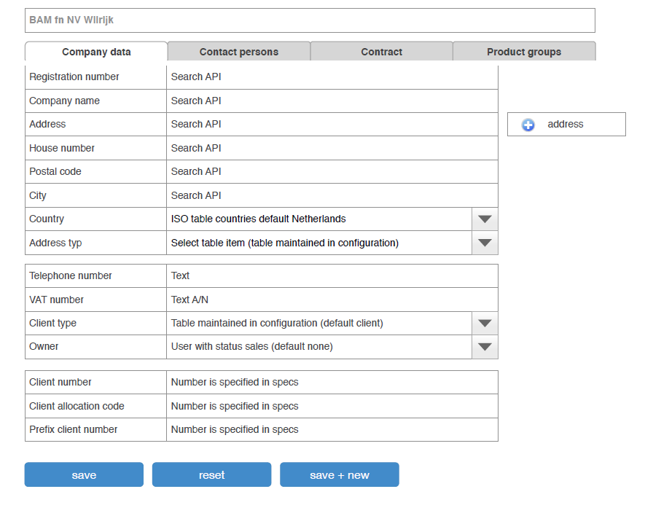

In the form above, the user will fill out the company data. Some data can be pre-filled by the company-search selection before.

Please ignore the tabs “Contract” and “product groups” for now, they will not be implemented yet. But bear in mind that there can be more tabs added in the future, and see the “Address” paragraph below.

Either the user has skipped search, or has selected a company from the search to reach the edit

### Address

The field address type can be removed, this should ALWAYS be of the type “office”. This cannot be changed. The address stored here will also be the “primary” address in all cases.

Please ignore also the button “+ address” on the right. This will be an extra tab.

## Client number

The **client number (in company table: field is number)** field should be an auto-generated (auto incremented) number:

from the distribution partner table you take the latest company_number_index, increment this with 1 and put the company_number_prefix in front. So the client number in the form will be for instance CD2. After saving the company as a NEW COMPANY, you will increment company_number_index with 1. So next time, the client number for a new client will be CD3.

Make preparations to be able to disable manually overriding this field in the form. We have to discuss if this field should give the option to let the user customize the number. In our opinion right now: display the number, but not edit it.

For easy use there should be a helper function somewhere in the codebase like “incrementDistributionAutonumberIndex($distributionPartnerId)” which will automatically add 1 to the company_number_index

**Client allocation number** corresponds to the field “number_distribution_partner” in the company database.

The field **prefix client number** can be ignored, do not add this to your form, this is used to construct the auto-numbering client number, it should not be displayed or entered here.